**Push the image to the IBM Cloud Registry**

1. From your account dashboard, go to **IBM Cloud Kubernetes Service**.
2. From the left navigation menu, select **Private Repositories**.

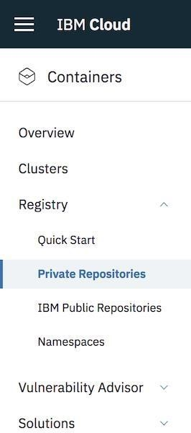

1. Install the Container Registry plug-in.

|  |  |  |
| --- | --- | --- |
| 4. | ibmcloud plugin install container-registry -r "IBM Cloud" |  |
|  |

1. Log in to your IBM Cloud account.
2. ibmcloud login -a <cloud_foundary_end_point_for_the_region>

1. Name and create your namespace. Use this namespace for the rest of the Quick Start.

|  |
| --- |
| ibmcloud cr namespace-add <namespace> |

8.

9. Log your local Docker daemon into the IBM Cloud Container Registry.

|  |
| --- |
| ibmcloud cr login |

10.

11. Choose a repository and tag by which you can identify the image.

|  |
| --- |
| docker tag <image_name> <region_url>/<namespace>/<image_name>:<tag> |

12.

13. Push the image.

|  |
| --- |
| docker push <region_url>/<namespace>/<image_name>:<tag> |

14.



15. Verify that your image is in your private registry.

16. ibmcloud cr image-list

